Exercise 1:

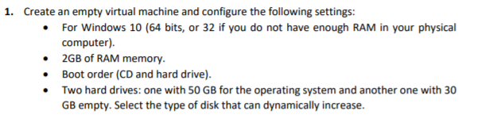

Step 1: We have to choose the OS that we want in this case Windows 10

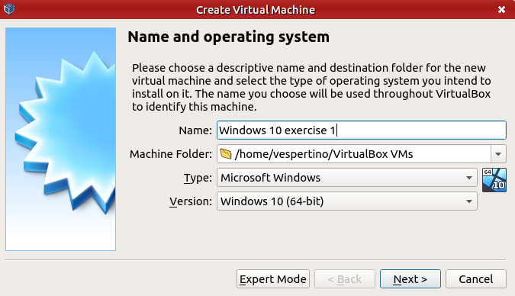

Step 2: The exercise say that we have to put 2GB of Ram so we are going to put this size in this window:

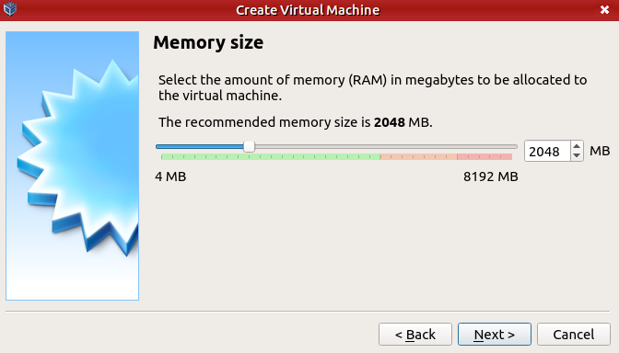

Step 3: For the boot of the OS you have to put the ISO first in the configuration window, for this you have enter in configuration you can enter clicking here:

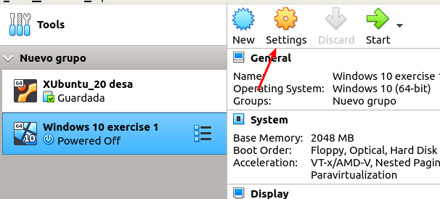

Step 3.b: When you are in settings you are going to “Storage” . then you are goint to select the disk with the name “Host Drive…”

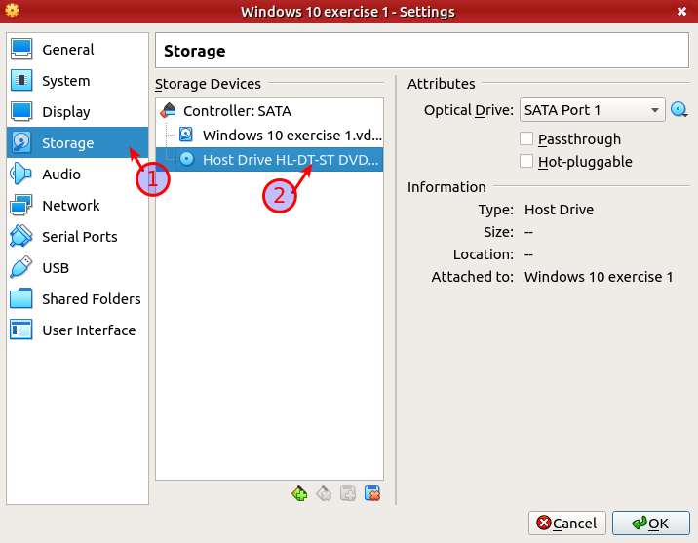

Now you have to click here and select the ISO that you want to use:

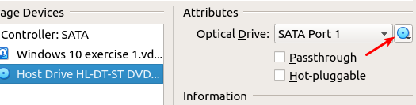

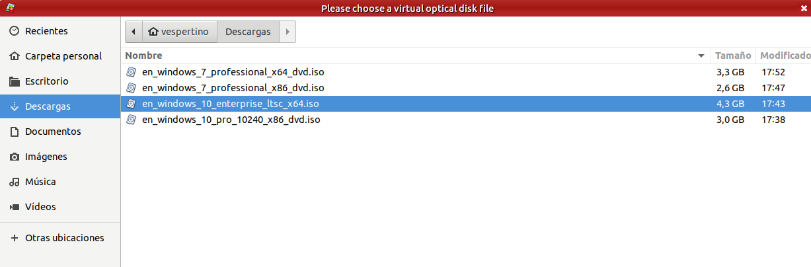

In this case we are going to use this version of Windows 10

Step 4: Now we have to put another dynamic disk with 30GB for this, we are going again to configuration:



Then we are goint to click in the “storage option” and click the next option:

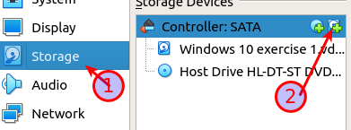

Now this window will open and we have to choose “Create” to add a new disk:

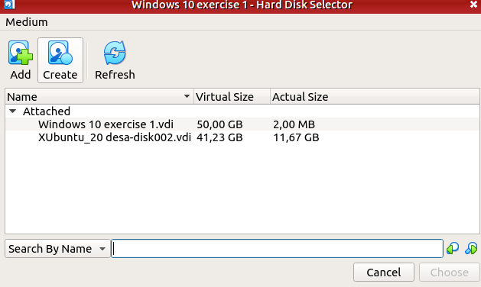

This window will open and you have to select first the hard disk file type, next if you want a dynamic or fixed size and then the size that we want in the disk:

1:

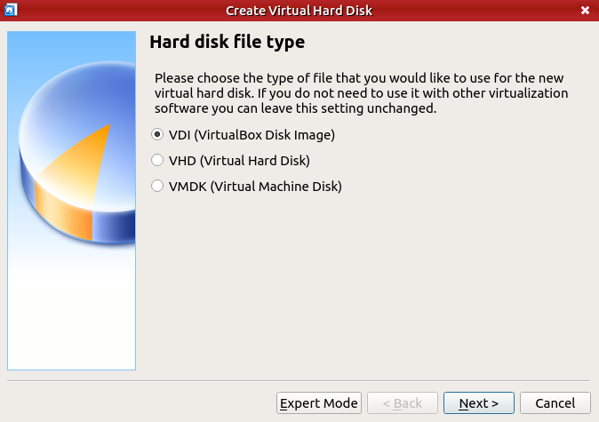

2.

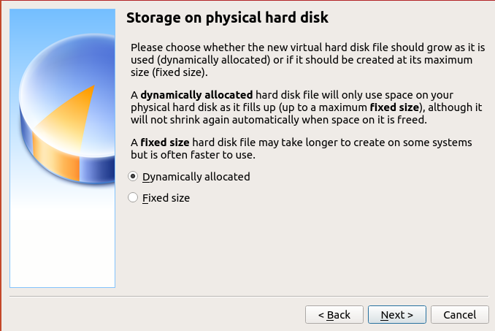

3.

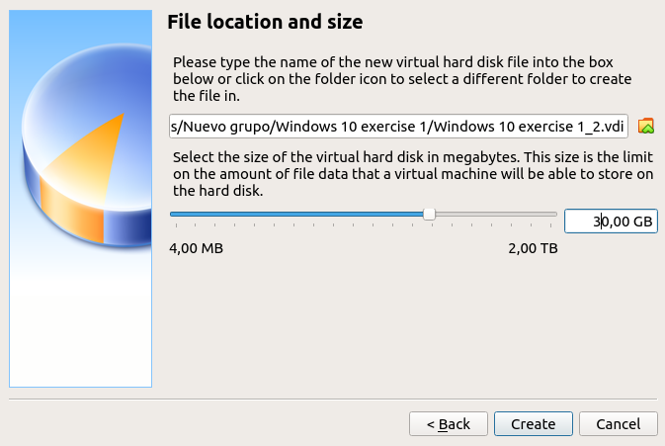

Then we have to click the create button, and now we have to select the disk that we have create and click the choose button:

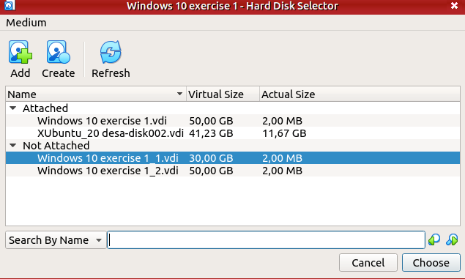

and that's all

Now we have to put the USB 3.0 support to do this we go to the settings and click in the usb section and select the 3.0 controller (all of this before the installation of the extension pack)

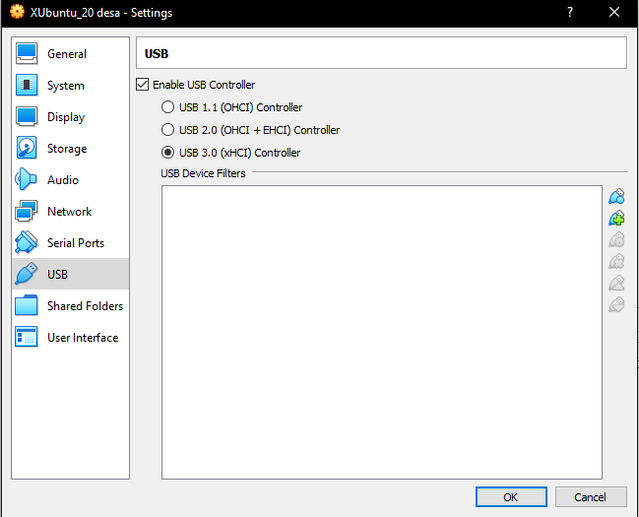

For share folders we have to go to the “shared folders” option:

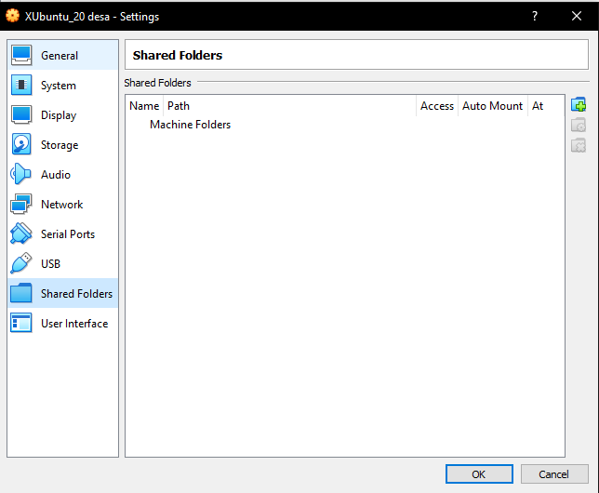

Now we click this button



And then put the folder path, folder and click the auto-mount option:

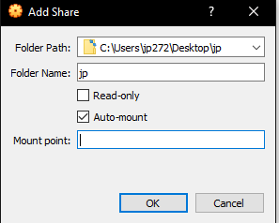

Now we need to change the network adapter to establish the connection with others computers we have to put the bridge adapter:

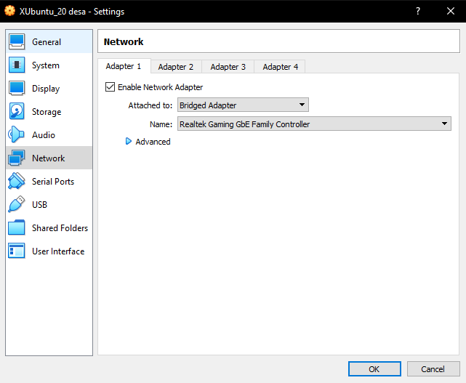

Now we have to configure the settings to copy and paste from the host to the guest:

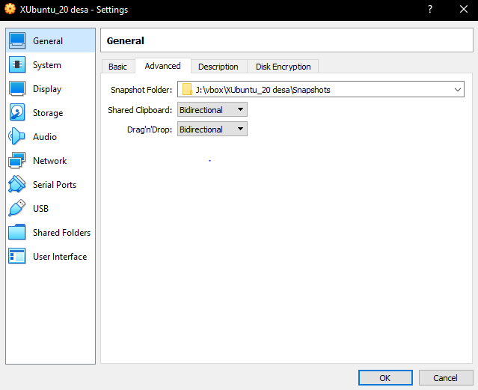

Let's check if it works